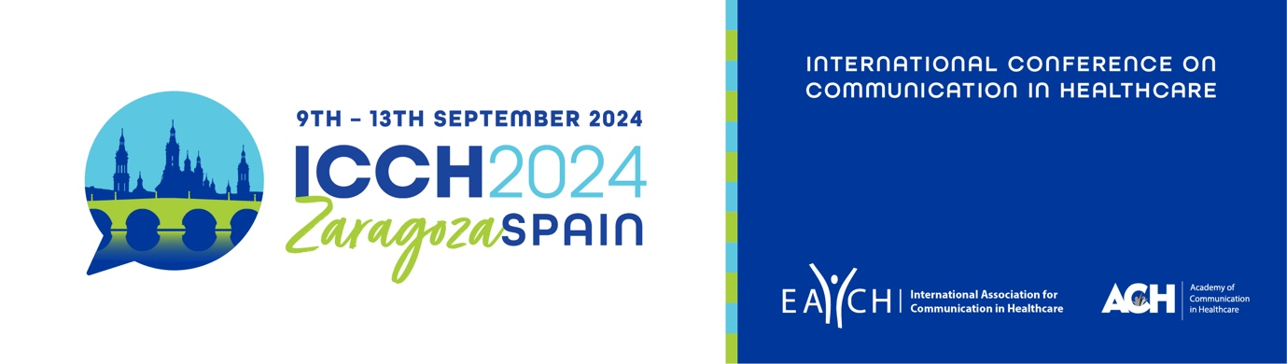

SCHOLARSHIP APPLICATION
FOR PRE-QUALIFICATION/UNDERGRADUATE STUDENTS

Applications are invited to the EACH Scholarship Fund, which provides a limited number of scholarships giving 50% discount on the EACH member conference registration fee.
These scholarships are available to pre-qualification/undergraduate students who are not able to afford the ICCH registration fee and have an accepted submission to present (e.g. oral, poster, workshop, symposium, roundtable) at the EACH-hosted ICCH 2024 in Zaragoza, September 2024.
Pre-qualification/undergraduate students already benefit from a reduced conference registration fee, but we wish to provide further support for students who are unable to afford this fee and whose institutions do not provide financial support for the conference.
Scholarships will be allocated on a first-come first-served basis, once applications have been screened for eligibility.
Interested students should fill out the form below and email it to info@each.international prior to registering for the conference, together with an accompanying letter from your institution/mentor confirming that you are a pre-qualification/undergraduate student and explaining that they are unable to provide financial support for you to attend the conference.
The final deadline for applications is Friday 31st May 2024. If you are selected to receive a scholarship you will be contacted by Friday 21st June 2024.

Date of application:
Name:
Institution:
Country:
Email address:
Abstract title:
Paper reference number:

