SimCode
User Guide: Version 1.0

Table of Contents
SECTION I: USING SIMCODE
Introduction:
Page 3
Chapter 1: Getting Started
Page 4
Chapter 2: Organizational Overview
Page 11
Chapter 3: Coding a Case
Page 12
Chapter 4: Data Exports
Page 18
SECTION II: COMMUNICATION TYPES

Chapter 5: Persuasion
Page 19
Chapter 6: Confirmation
Page 21
Chapter 7: Disconfirmation
Page 23
SECTION III: (OPTIONAL) SPEECH AND AFFECT

Chapter 8: Affect Ratings
Page 26
Chapter 8: Speech Ratings
Page 32
SECTION IV: (OPTIONAL) RELATIONAL COMMUNICATION

Chapter 10 Affect Ratings
Page 40

Introduction
An introduction to the SimCode Manual

An important feature of communication theory is the idea that communicators, through verbal and nonverbal communication, can convey multiple layers of messages, often defined as the content and relational levels of communication. In this sense, communication can be understood as providing two streams of meaning: one that regards the denotative content of a message and another that reflects the affective tone. Because of this, the relational meaning may reveal important relationship dynamics that may not be revealed by a single analytic approach. SimCode provides a flexible system that assesses both the content and relational communication between two or more interactants and can be adapted by the researcher to capture relevant information for the research question at hand. More specifically, the program captures: a) task driven information exchange between multiple interaction partners, b) the affective and relational communication activities of all communicators, and c) the persuasion and compliance tactics employed in healthcare settings that contribute to decision-making.

Coding qualitative data
In the field of behavioral health sciences, there is the challenge of converting qualitative information into meaningful quantitative data or retaining its qualitative structure while enabling its systematic analysis. When the qualitative data set is large and there are multiple trails of data, the task becomes difficult. The SimCode application is designed to fulfill this purpose – to convert qualitative information into quantitative data, allow verbatim transcription as desired, and provide easy access to aggregated data. SimCode is available as a online program that requires each university to provide server space for it, similar to REDCap. SimCodellows multiple users to enter and alter data seamlessly.

Chapter One
Getting Started

I: The Welcome Screen
After navigating to the SimCode site, users will be greeted with a welcome screen that provides information about the product version that is being used. Enter your Temple University credentials (AccessNet and password) to log in.

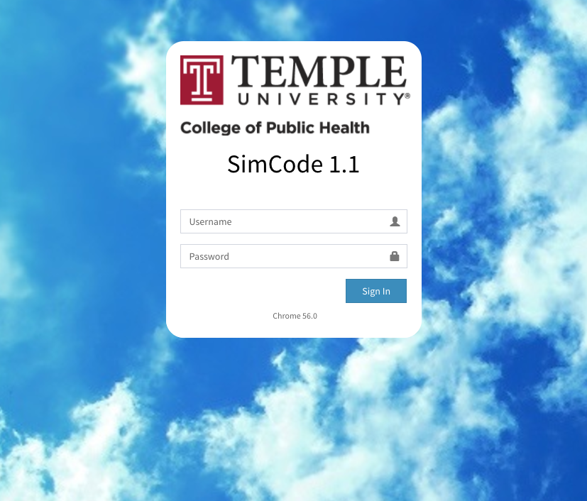

II: The Main Screen
The Main Screen is the first screen that is presented to users after the Welcome Screen. It shows the role of each user (Admin, Manager, or General), shows the studies available under each category (Open, Development, or Archieved), the reporting options, and creating a new case

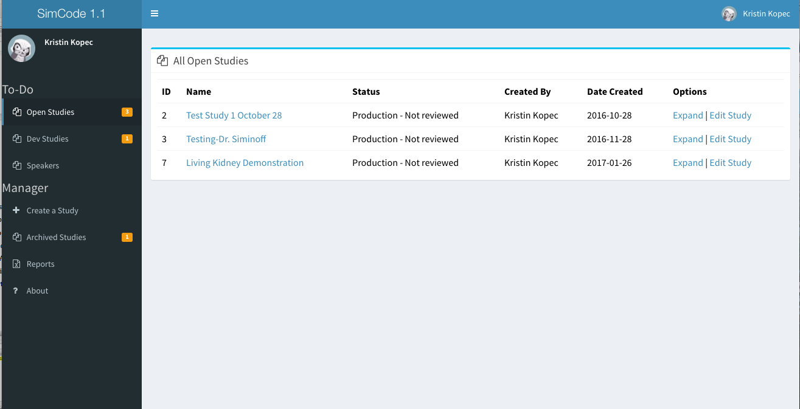

III: Creating a Template

Templates are created by the administrator, Jeremy Shafer or Jemin Patel. Templates should be prepared in an Excel File, with the major topic headings and subtopics for content codes and for decisions. Speech, affect, and communication types should be prepared similarly. If you would prefer not to adapt the speech, affect, and communication types, the standard templates are available.

IV: Creating a New Study (Managers Only)

To create a new study, select “Create a New Study” from the toolbar on the left. Note: Only managers will be able to create a new study. The section allows you to name the study, add comments, select a template, and add users to the study. You will only be able to add users who have been assigned to you as a manager. As a manager, you will automically be added as a user. You will also select a template for the study. Each new study will automatically be added as a “Development” Study.

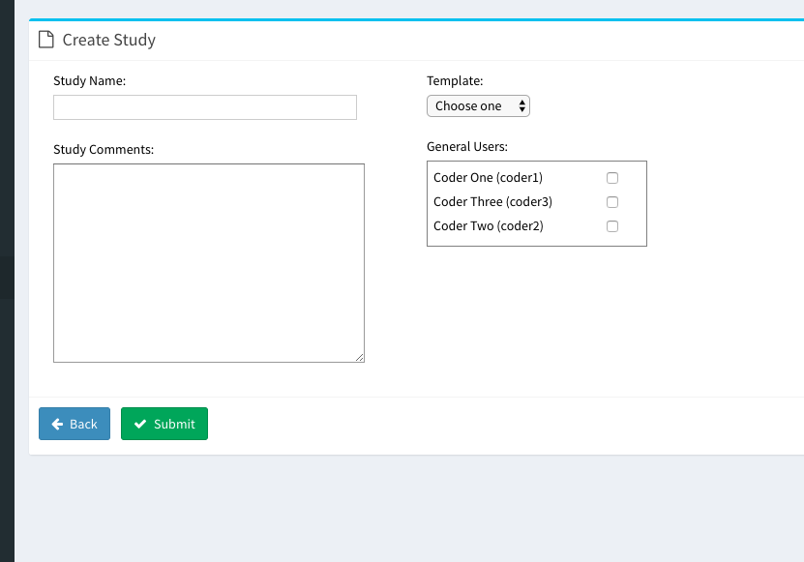

V: Opening the Study

Using the left-hand tool bar, navigate to the development studies (“Dev Studies”). You should see your study here. Click on your study name to see the drop down option of adding a case.

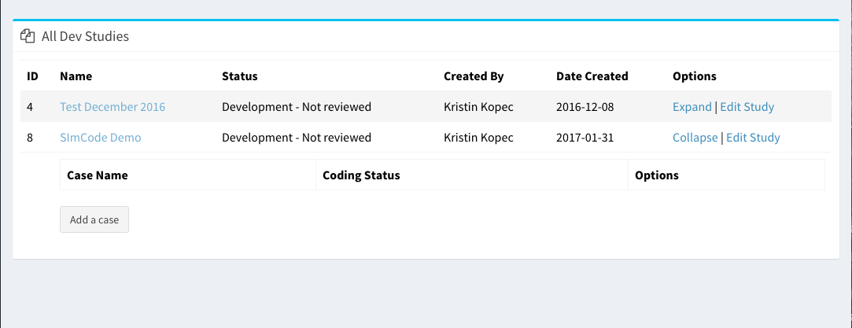

VI: Creating a Case
From here, add your case name, transcript, and site. Currently, transcripts from Word have some problems with the formatting, so it is best to use transcripts from a .txt file. Simply copy and paste your transcript into this box, and hit submit.
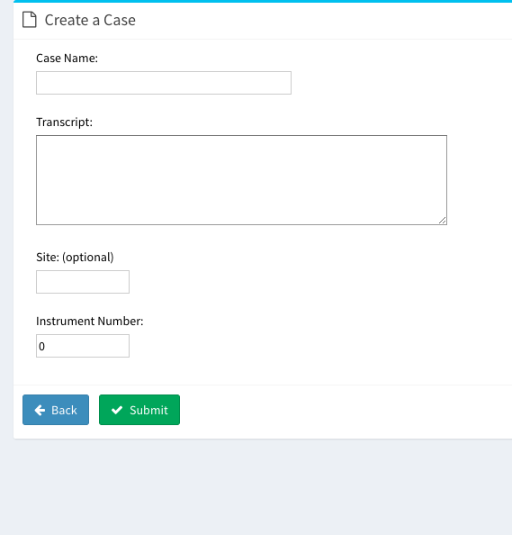
VII: Opening a case
After you create a new case, it will be added under the study. To open the case, click on the study name or ‘Expand Study”, and all the cases should appear. Under the Options section, you can select
- Edit: takes you to the coding section
- Delete: deletes that case
- Speakers: allows you to edit the speakers in the case
- Info: shows the number of utterances, communication tags, and decision tags

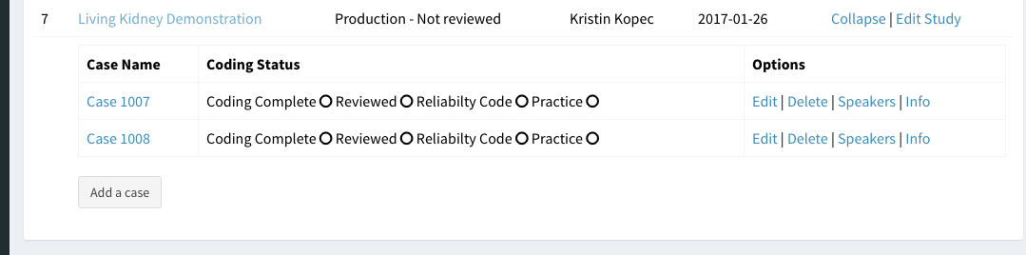

VIII: Adding speakers
From the options tag, select Speakers. From here, you will get a list of all the speakers available for the study. You can add a speaker to this case by changing them from No to Yes under the last column, “In Case”. New speakers can also be added using the last line of this box. Speakers are categorized as HCP (healthcare provider), NOK (next of kin), or PT (patient). They are also given a Speaker ID and the option of including details about the speaker.
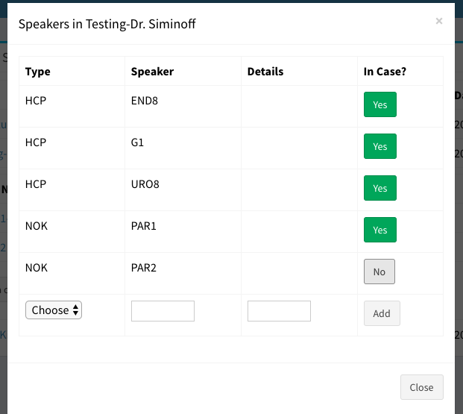
IX: Moving from Development to Production or Adding Users
After you have thoroughly tested your case and trained all the coders, the next step is to move the case to production. To do this, click on “Dev Studies” from the left hand tool bar, select “Edit Study”, and then change the status from Development to Production. This is the same way that studies will be changed from Production to Archived, as well as the reviewed status changed. This section also allows you to add additional coders. The “Edit Study” option is also available for studes in production.

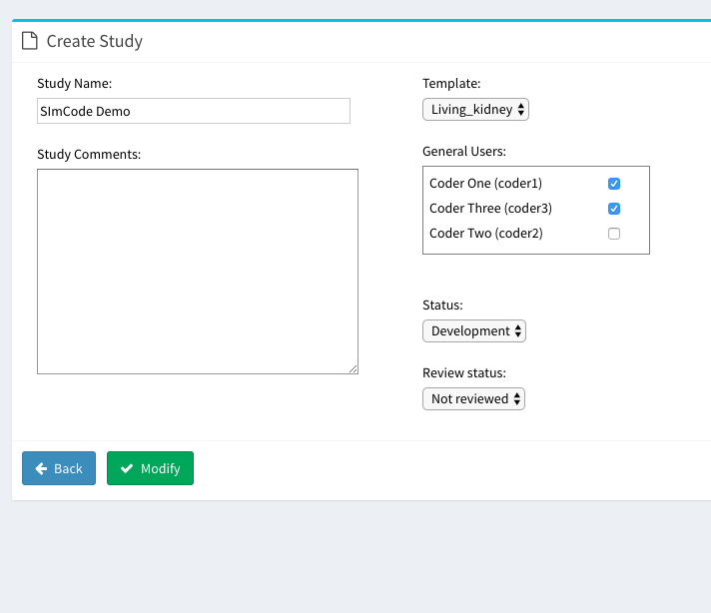

Chapter Two
Organizational Overview

I: User Types
There are three roles of users:
- General: Appropriate for undergraduate students or research assistants. Can access studies, create new cases, and code cases.
- Manager: Appropriate for a PI or Study Coordinator. Can do everything that a general user can plus create studies, move studies between development and production, assign projects to general users
- Administrator: Jemin/Jeremy has all rights to make accounts and upload templates
Users are assigned to a role at the time their account is created.
II: Study Status
There are three statuses that a study can be classified as:
- Development Studies: Similar to REDCap, this provides a site where templates can be tested and created. This is also a great section to use for training purposes.
- Open Studies: This section is for studies that have a developed template. Cases are actively being added and coded.
- Archived Studies: This section is for studies that have been completed.
III: Study/Case Organization
Each study appears on a separate line under its status. A study will always appear in the same status across all users. Each study is assigned an ID-these are based on the order the study is created and are not relevant. Studies may not have the same name.

Nested underneath each study are cases. These are generally named the same as their study ID.

IV: Coding Status
Each case can be assigned to four statuses:
- Coding Complete: The case has been coded fully, including all utterances, decision tags, communication types, and speaker ratings
- Reviewed: The case has been reviewed, usually by a second coder
- Reliability: This case has been selected as a reliability case
- Practice: This case is just a practice case, usually for training purposes
Note: Cases may be assigned multiple statuses-for example, a case may be labeled coding complete and a reliability case.

V: Security and HIPAA Compliance
At Temple Univeristy, SimCode is hosted on the same server and level of security as REDCap, and is HIPAA compliant. Do not store information such as credit card numbers or social security numbers on SimCode. It is also prudent to remove identifying information, such as names and cities, from the transcripts before pasting them into SimCode.

Chapter Three
Coding a case
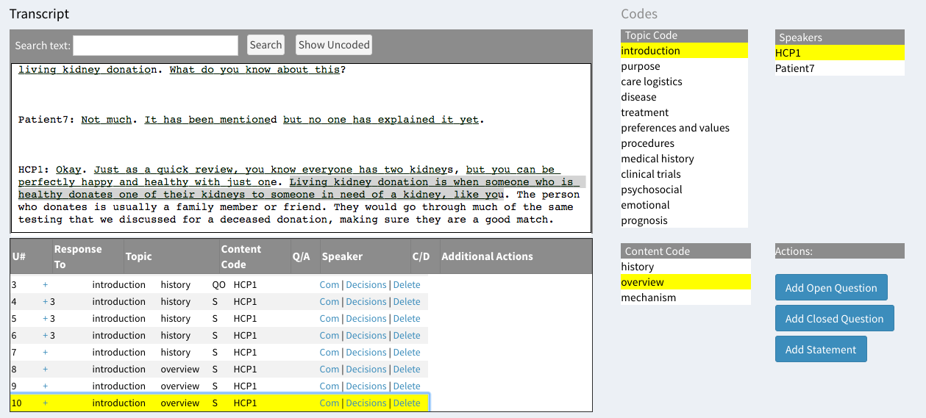
I: Utterances
To code an utterance, highlight the utterance in the transcript section, select the major topic code, the content code, a speaker, and then select “Add Open Question”, “Add Closed Question”, or “Add Statement”, depending on that type of utterance this is. One an utterance has been coded, it will be underlined in the transcript box. It will also appear in the second box, along with:
- Utterance number: this is fluid and may change if previous utterances are added or removed. This is included for the purpose of question/response tracking
- Response to: (See question/response section below)
- Topic: the topic selected for the utterance
- Content Code: the content code selected for the utterance
- Q/A: the type of utterance, whether it is a statement (S), open ended question (QO) or closed ended question (QC).
- Speaker: the speaker of the utterance
- C/D: The presence of a C indicates there is a communication type associated with the utterance; the presence of a D indicates a decision

II: Questions and Responses
In order to designate an utterance as a response to a question, click on the plus sign of the answer utterance. This will turn all of the other plus signs into a yes or no question, asking whether this utterance is a response to all of the other utterance. Change this option to yes for the question(s), and click done.

One question may have multiple answers, and one utterance may answer multiple questions.
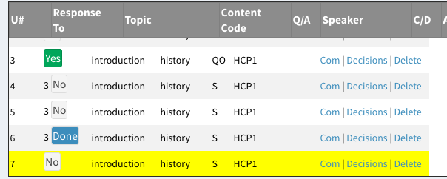
III: Adding or Deleting Utterances
Deleting utterances is very easy-simply select “Delete” under the additional actions tab to remove an utterance. After it has been removed, it will no longer show up in the lower box and it will not be underlined.

To add an utterance, such as one that had been skipped in the earlier coding, simply add it as you would an utterance at the end of the transcript. The utterance numbers and response to it will automatically adjust.
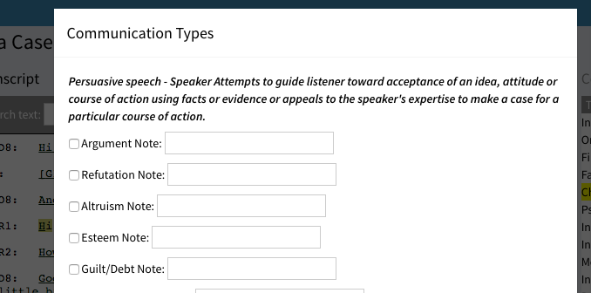

IV: Adding a tag for Communcation Type
To add a communication type, first code the utterance by content. Next, select “Com” from the additional actions tab. This brings up a long list of communication type options. Select the communication type(s) that apply, scroll to the bottom of the pop-up screen, and select close.

Communication types are standard across all SimCode studies.

V: Adding a Decision Tag
To add a decision tag, first code the utterance by content. Next, select “Decisions” from the additional actions tab. This brings up a long list of decision tag options. Select the decision tag(s) that apply, scroll to the bottom of the pop-up screen, and select close.

Decision tags are customized for each study.

There is no limit on the number of decision tags and communication types that may be assigned to each utterance.

VI: Speech and Affect Ratings
To view the speech or affect ratings, click on the plus sign. This will drop down all of the speakers in the case. Select the speaker, then assign ratings to them. The rating will appear bolded and blue. For data management purposes, all speakers should have a rating, even if they are rated as N/A. This helps distinguish between speakers who are intentionally not rated versus those who were accidentally skipped.

Speech and affect ratings are customized to the study, though there is a standard template available.

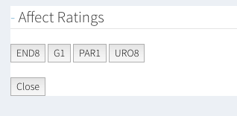
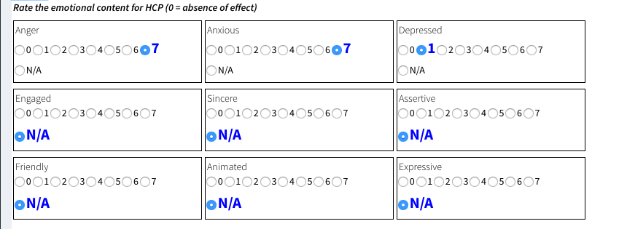

VII: Finishing up
Once a coder has completed a case, the case should be marked “Coding Complete”. There are additional tags that may be used for study organization as well. See Chapter 2, Part IV for a more detailed explanation.

Chapter Four
Data Exports
I: Reports Available
Data are available as exports in four excel sheets. Each can be accessed through the “Reports” tab in the left-hand column. Selecting this will take you to the exports page. Reports are organized by study. Each report will export as a .csv file.

*Note: Only “Open Studies” are available for exports

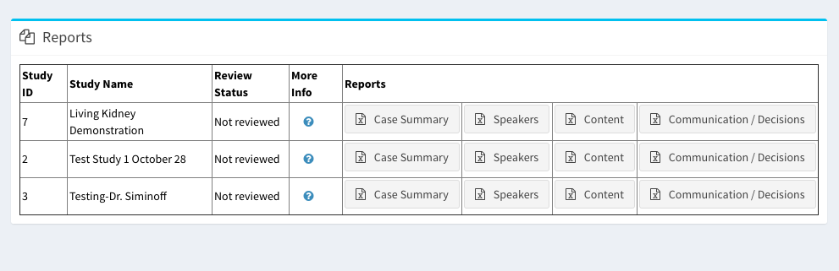

II: Case Summary
This provides a quick overview of the cases, and would be a good place to start for a progress report. Each line represents one case, and includes the number of utterances, decision tags, communication tags, the coder, the speakers, and the status of the case (coding complete, reviewed, reliability, practice).

III: Speakers
This contains the information on the speech, affect, and relational communication ratings. Each line represents one speaker in one case. Ratings can be averaged by case or by speaker if a speaker is present in multiple cases.

SECTION II. COMMUNICATION TYPES
Chapter 5:
Persuasion

In effective communication, these are verbal attempts to guide another toward acceptance of an idea, attitude, or course of action without using force or threats. Individuals deliberately try to convince others to change their attitudes or behaviors regarding an issue through the transmission of a message in an atmosphere of free choice.

Argument: Using facts to make a case for a particular course of action. An argument is based on some kind of proof or evidence. Proof can take the form of experience, expertise, or other empirical data.

Refutation: (also referred to as “Countering”) A rebuttal or counterpoint to an argument. Use REFUTATION when a factual response is offered to dispel a previously expressed claim or argument.

Altruism: A reference to helping others, being unselfish, or generous.

Esteem: Referring to the positive perceptions of others if the interactant complies.

Guilt/ Debt: Messages that induce a feeling of responsibility or remorse for some offence, either real or imagined. Pointing out inconsistencies with past expressed thought or action. Causing one to feel remorse for some offence.

Foot in the Door: A small request followed by a larger one.

Emphasis: This occurs when the speaker attempts to persuade the other by placing great importance on what is being said. This can be indicated by tone of voice, repetition, or other cues (such as a direct verbal statement) used by the speaker. Emphasis is NOT indicated when the speaker uses argument to make their case, if someone repeats themselves just to make sure the listener heard and/or understood, or if the listener asks for repetition.

Credibility: Attempts to gain trust by citing affiliation, professional credentials, or goodwill.

Chapter 6:
Confirmation
Confirming communication acknowledges the worth, experience and worldview of another person. These messages function to connect speakers on a relational level. They can be expressed in several verbal message forms.

Approval: Speaker endorses a statement made by, or course of action of, another person.

*Note: Sometimes approval is expressed in simple, single-word endorsements: good, great, terrific, beautiful, etc. Be aware that “okay” is often used simply to signal understanding and should not be coded as approval.

Repetition/ Clarification: (also referred to as just “Repetition”) Repetition functions to emphasize the speaker’s affect or thoughts by repeating or paraphrasing another’s statements. A speaker will use clarification to pinpoint details or to clear up uncertainties. Repetition/ Clarification is confirming because it indicates connection with the speaker’s idea and signals respect by checking in.

*Note: When repetition is used as an information-gathering convention, such as in a medical history conversation, do not code as repetition. Also, the solicitation of repetition is NOT tagged as repetition

Offer of Service: The speaker offers a service beyond typical expectations of their position.

*Note: Do not tag “offer of service” if the offer is a typical job responsibility (such as calling the hospital to determine the donor’s eligibility.)

Concern/ Empathy: (also referred to as just “Empathy”) Statement that recognizes or reflects another speaker’s emotional state. Use concern/empathy to denote expressions of compassion. This tag reflects the spirit of identification or “standing in the other’s shoes.”
Note: Do not tag Concern/ Empathy for simple descriptive expressions not directed toward the individual’s emotional well-being. Emotional language is not enough – it must be person-centered. The connection to the other must be a feature in the utterance. Do not code concern/empathy for simple statements of understanding.

Legitimize/Acknowledge: (also referred to as simply “Legitimize”)- Speaker normalizes the other’s actions, emotions, or behaviors by indicating that they are common/universal. This tag can also be used when the speaker indicates understanding of the other’s expressed concerns.

*Note: Do not use Legitimize/Acknowledge if the utterance expresses hearing rather than understanding the other.

Apology: -Apologies are instances when the speaker says: “I’m sorry” or asks for forgiveness. Apology should be coded if the speaker apologizes for mental lapses, interruptions, or other breaches of expected protocol.

*Note: Saying “I’m sorry” can function as either a response to a breach of protocol (e.g., interruptions, forgetfulness, other failures to act as planned) or can function as an act of compassion. Do not code Apology when “I’m sorry” is used in place of “excuse me” or “please repeat”. Also, do not use this Comm. type tag for “Negative Apologies” wherein the TR apologizes for having to do their job. There is a Negative Apology decision tag. See the coding manual for more information.

Reassurance: Utterances that address someone else’s uncertainty, concerns, or anxiety, with the intent of providing support or bolstering confidence or optimism. Use Reassurance when the speaker is supporting the other through some unknown future.

*Note: Do not code Reassurance when the speaker expresses a favorable opinion toward an event that has already occurred.

Laughter (+): Any audible moments of shared laughter or joking. Often takes the form of sarcasm or self-deprecation. Only code Laughter (+) if both speakers recognize and respond favorably to the point of humor. The content of shared laughter is often embedded in nonverbal vocal intonations that cannot be discerned from text or transcript, unless the transcriptionist indicates laughter. Both speakers do not have to actually laugh – one can make a joke and the other can laugh at the joke. Nonverbal (vocal) tone is very important here for judging sarcasm or joking intent. Listen for stresses, unexpected change in volume or pitch.

*Note: In the event the utterances are not clear but the shared laughter is clear, then go ahead and code Laughter (+). You can type “comment unclear” in the text box.

Use of Personal Examples: Attempts to make a connection with another individual on a more superficial level by using personal stories or anecdotes.

Self-Disclosure: Attempts to make a connection with another individual on a deeper or more personal level using personal stories or anecdotes.

Chapter 7:
Disconfirmation

Messages that devalue another’s worth, experience or worldview or negate the other’s thoughts and feelings. These messages are all a nonresponse in various ways. Some connect partially, some not at all, and some in a negative or even hurtful way. Disconfirming messages are typically considered in the context of the utterance that precedes it.

Disapproval: Speaker disagrees with, criticizes, or puts down ideas or a course of action relevant to the other.

Ambiguous: Equivocal responses that are vague, unclear, or open to more than one possible meaning. Ambiguous utterances are marked by uncertainty.

Indifferent: An indifferent response is a failure to respond appropriately to another’s message. This could include talking over the other, silence in response to a question, side conversations with others, or even overelaboration. The key to recognizing an indifferent response is the lack of interpersonal connection, aloofness toward the other speaker, or ignoring the speaker’s attempt to communicate key information. One-sided or unshared laughter may also be tagged Indifferent.

Tangential: Tangential responses give the impression of a direct connection but skirt the other’s main intent. Tangential responses may start with the speaker seemingly addressing the topic at hand, but then veering off onto a different subject. Tangential pays a little lip service to the other but never really connects the two speakers. The tangential response falls short of attending to the real concern.

Disparaging: Demeaning remarks are utterances that slight, put down, or belittle. The object of a disparaging utterance is personal.

Irrelevant: Extraneous, off-the-subject remarks, topic switch without explanation. Irrelevant utterances are completely disconnected from the preceding utterance. These differ from Tangential utterances in that they pay NO lip service to the original point/concern; the previous topic is simply ignored.

*Note: An utterance can be both irrelevant and indifferent and should be coded as both.

Laughter (-): Any audible moment of laughter that is not only not shared, but is at the expense of the other. This may take the form of mocking, or insensitivity to the feelings of the other, and may often accompany a disparaging remark, or a remark of disapproval. Negative laughter may also take the form of uncomfortable, or nervous non-shared laughter at one’s own expense.

Jargon & Euphemisms: Remarks that consist of language that is not commonly understood, and that indicates or places a barrier between the speakers. Use of jargon includes using words and/or phrases that are not common knowledge, while euphemism is the substitution of a mild, indirect, or vague expression for one thought to be offensive, harsh, or blunt. Also may refer to the use of euphemistic words/phrases that circumvent the issues at hand, indicating a disconnect between the speakers.

Stop Interruption: These are utterances that step on the speech of the other speaker. These utterances not only interrupt the other speaker, but change the subject entirely away from what the first speaker was originally on.

Cut Off Interruption: These are utterances that step on the speech of the other speaker. These utterances interrupt the other, but stay on the same topic.

SECTION III. SPEECH AND AFFECT
Chapter 8:
Affect
An observed emotional expression or response, such as the expression of pleasure, anxiety, sadness, or other subjectively experienced states.

I: Patient/NOK Affect
Rate the emotional content for the Patient:
Scale is 0 to 7. The anchor points for each scale are defined below.
*Note: Infrequently occurring affects are rated on a temporal scale, rather than a scale that denotes intensity.

Anger: Exhibiting a strong feeling of displeasure or hostility.
0= Never angry: Patient portrays a complete absence of anger.
1-3= Rarely to occasionally angry: Patient sounds angry some of the time.
4= Sometimes angry: Patient sounds angry a good deal of the time.
5-7= Often to very often angry: Patient sounds angry nearly all the time.

Anxious: Characterized by worry or nervousness.
0= Not anxious: Patient sounds as though s/he has no anxiety throughout the conversation; relaxed.
1-3= Slightly to somewhat anxious: Patient sounds slightly uneasy, but does not sound generally uncomfortable interacting with the HCP.
4= Moderately anxious: Patient sounds as though s/he has a moderate level of anxiety throughout the conversation. Generally sounds uneasy, but not incredibly distraught or distressed.
5-7= Very to extremely anxious: Patient sounds distraught throughout the conversation; displaying a high level of discomfort and unease.

Depressed: Sad and gloomy; dejected; downcast.
0= Not depressed
1-3= Slightly to somewhat depressed
4= Moderately depressed
5-7= Very to extremely depressed

Engaged: Connected and involved with the other speaker.
0= Not engaged: The Patient interrupts the HCP frequently, fails to acknowledge or seems disinterested in what the HCP is communicating; the Patient seems extremely distracted.
1-3= Slightly to somewhat engaged: Patient seems slightly distracted, uninterested, or withdrawn- i.e. spends an inordinate amount of time on tangential or irrelevant issues.
4=Moderately engaged: Patient confirms that s/he is interested in what the HCP is saying and seems generally focused.
5-7= Very to extremely engaged: Patient seems unusually interested in what the HCP is saying.

Sincere: Patient sounds honest, straightforward, and genuine and does not obfuscate symptoms or role details.
0= Never sincere: The Patient never shows sincerity.
1-3= Rare to occasionally sincere: The Patient shows sincerity some of the time.
4= Sometimes sincere: The Patient shows sincerity a good deal of the time.
5-7= Often to very often sincere: The Patient shows sincerity nearly all the time.

Assertive: Shows confident, firm, and self-assured behavior.
0= Not assertive: The Patient often wavers and seems timid and unsure in statements to the HCP.
1-3= Slightly to somewhat assertive: The Patient sounds somewhat confident and strong in statements to HCP but occasionally sounds unsure.
4= Moderately assertive: The Patient sounds confident in the information given to HCP, and sounds assured about symptoms.
5-7= Very to extremely assertive: The Patient sounds overly confident and self-assured. S/he may even sound demanding or argumentative.

Friendly: Expresses liking, congeniality, and amiability.
0= Not friendly: The Patient sounds hostile.
1-3= Slightly to somewhat friendly: The Patient sounds disagreeable to indifferent, i.e. does not engage in social niceties.
4= Moderately friendly: Patient sounds genial, i.e. engages in appropriate shared laughter, social niceties, and pleasant tones of voice most of the time.
5-7= Very to extremely friendly: Patient engages in a significant amount of social chitchat, joking, or other social niceties nearly all the time.

Animated: Lively and vigorous.
0= Not animated: The Patient’s tone does not sound at all spirited; flat.
1-3= Slightly to somewhat animated
4= Moderately animated
5-7= Very to extremely animated: The Patient’s tone sounds spirited, bubbly, and/or vivacious.

Expressive: Speaker is able to convey his/her feelings or ideas successfully, eloquently, and/or meaningfully.
0= Not expressive
1-3= Slightly to somewhat expressive
4= Moderately expressive
5-7= Very to extremely expressive

II: HCP Affect Rating

Anger: Exhibiting a strong feeling of displeasure or hostility.
0= Never angry: HCP portrays a complete absence of anger.
1-3= Rarely to occasionally angry: HCP sounds angry some of the time.
4= Sometimes angry: HCP sounds angry a good deal of the time.
5-7= Often to very often angry: HCP sounds angry nearly all the time.

Anxious: Characterized by worry or nervousness.
0= Not anxious: HCP sounds as though s/he has no anxiety; relaxed.
1-3= Slightly to somewhat anxious: HCP sounds slightly uneasy, but does not sound generally uncomfortable interacting with Patient.
4= Moderately anxious: HCP sounds as though s/he has a moderate level of anxiety throughout the conversation. Generally sounds uneasy, but not incredibly distraught or distressed.
5-7= Very to extremely anxious: HCP sounds distraught; displaying a high level of discomfort and unease.

Depressed: Sad and gloomy; dejected; downcast.
0= Not depressed
1-3= Slightly to somewhat depressed
4= Moderately depressed
5-7= Very to extremely depressed

Engaged: Connected and conversant with the other speaker.
0= Not engaged: HCP interrupts the Patient frequently, does not acknowledge or seems disinterested in what the Patient is communicating, and/or fails to answer the Patient’s questions. The HCP also seems extremely distracted and disconnected from the conversation.
1-3= Slightly to somewhat engaged: HCP seems slightly distracted- i.e. HCP spends an inordinate amount on tangential or irrelevant issues, has lengthy, unrelated, chats with the Patient, or sounds generally unfocused.
4= Moderately engaged: HCP confirms that s/he understands and is interested in what the Patient is saying.
5-7= Very to extremely engaged: HCP seems unusually interested in what the Patient is saying all of the time.

*Note: A ranking of ‘4’ is the normative anchor point.

Sincere: HCP sounds genuine, straightforward, and honest.
0= Never sincere: HCP never sounds sincere.
1-3= Rarely to occasionally sincere: HCP sounds sincere some of the time.
4= Sometimes sincere: HCP sounds sincere a good deal of the time.
5-7= Often to very often sincere: HCP sounds sincere nearly all the time.

Assertive: Shows confident, firm, and self-assured behavior.
0=Not assertive: S/he does not portray definitive and positive behavior. HCP sounds unsure in statements to Patient.
1-3= Slightly to somewhat assertive: S/he sounds somewhat confident when addressing the Patient, but occasionally sounds unsure.
4= Moderately assertive: S/he confidently provides information to the Patient.
5-7= Very to extremely assertive: HCP is unwavering in his or her decisions to the extent that s/he may disregard the Patient’s wishes.

Animated: Lively and vigorous.
0= Not animated: The HCP’s tone does not sound at all spirited; flat.
1-3= Slightly to somewhat animated
4= Moderately animated
5-7= Very to extremely animated: The HCP’s tone sounds spirited, bubbly, and/or vivacious.

Friendly: Expresses liking, congeniality, and amiability.
0= Not friendly: The HCP is particularly disagreeable throughout the conversation.
1-3= Slightly to somewhat friendly: The HCP sounds friendly some of the time.
4= Moderately friendly: The HCP sounds friendly most of the time; i.e. engages in a moderate amount of social chitchat and laughs appropriately.
5-7= Very to extremely friendly: HCP sounds friendly nearly all the time. S/he engages in a significant amount of social chitchat, joking, or other social niceties, in some situations distracting the HCP from his or her primary tasks.

Expressive: Speaker is able to convey his/her feelings or ideas successfully, eloquently, and/or meaningfully.
0= Not expressive
1-3= Slightly to somewhat expressive
4= Moderately expressive
5-7= Very to extremely expressive

Chapter 9:
Speech
The expression of or the ability to express thoughts and feelings by articulate sounds.
Scale is 0 to 7. The anchor points for each scale are defined below.

*Note: Infrequently occurring affects are rated on a temporal scale, rather than a scale that denotes intensity.

I: Patient Speech Rating
Monotone: Increase from zero if the Patient sounds flat or unvaried in tone.
0= Not Monotone
1-3= Slightly to somewhat monotone
4= Moderately monotone
5-7= Very to extremely monotone

Rate of Speech: How fast the Patient is speaking.
0= Extremely slow
1-3= Very slow to slow
4= Average
5-7= Fast to very fast
*Note: regional accents may make people speak faster or slower. This should not influence coder’s rating of the Patient’s rate of speech.

Sound Scripted: Patient sounds as though they are giving a rehearsed presentation of symptoms. A Patient that does not ‘sound scripted’ will seem as if they are expressing authentic thoughts, emotions, and experiences.
0= Never scripted
1-3= Rarely to occasionally scripted
4= Sometimes scripted
5-7= Often to very often scripted

Speaks clearly: Patient does not jumble their words and is easily understood.
0= Not clearly
1-3=Slightly to somewhat clearly
4= Moderately clearly
5-7= Very to extremely clearly

Control of Conversation: Similar to “Tries to Control Interaction”—i.e., Patient interrupts the HCP, monologues excessively, and/or withholds information.
0= Not controlling
1-3= Slightly to somewhat controlling
4= Moderately controlling
5-7= Very to extremely controlling

Hesitancy: Communication that sounds uncertain or wavering.
0= Not hesitant
1-3= Slightly to somewhat hesitant
4= Moderately hesitant
5-7= Very to extremely hesitant

*Note: Excessive use of non-words, tonality, and/or pausing mid-sentence may imply hesitancy (i.e. Um what we want to do uh may be…)

Use of Direct Communication: Indirect communication is indicated by the use of euphemisms, aphorisms, similes, or “beating around the bush.” For example, this code is useful in capturing instances that the Patient does not say exactly what s/he means.
0= Not direct: Uses indirect language frequently.
1-3= Slightly to somewhat direct: Occasional use of indirect communication.
4= Moderately direct: The Patient speaks in a straightforward, direct manner.
5-7= Very to extremely direct: Blunt.

Encourages talk: The Patient interrupts and controls the conversation, or conversely asks open-ended questions about diagnoses and/or engages in or initiates chitchat.

0= Never encourages talk: The Patient responds with closed-ended statements and never initiates conversation.
1-3= Rarely to occasionally encourages talk: The Patient engages in social nicety occasionally, but is generally reserved and does not ask open-ended questions.
4= Sometimes encourages talk: Indulges in social nicety appropriately but rarely asks open-ended questions.
5-7= Often to very often encourages talk: The Patient asks many open ended questions and engaging in frequent social chitchat.

Use of inclusive pronouns: Inclusive pronouns are common in participatory communication styles. Examples of this include statements such as, “so what we want to do” or “so what we are going to do today.” Inclusive pronouns only include the HCP and Patient—not “royal we” – and may indicate shared decision-making.
0= Never
1-3= Rarely to occasionally
4= Sometimes
5-7= Often to very often

Use of fillers: Uses nonwords such as ums and ers to fill in gaps between words.
0= Never
1-3= Rarely to occasionally
4= Sometimes
5-7= Often to very often

Response to disease info: Rate the speaker’s level of distress exhibited in response to information about a disease.
0= Not Distressed
1-3= Slightly to Somewhat Distressed
4= Moderately Distressed
5-7= Very to Extremely Distressed

Response to treatment: Rate the speaker’s level of engagement in the development of a treatment plan. (i.e. how active is the speaker in the discussion?)
0= Not Engaged
1-3= Slightly to Somewhat Engaged
4= Moderately Engaged
5-7= Very to Extremely Engaged

Response to side effect info: Rate the speaker’s level of distress exhibited in response to information about side effects of proposed treatments.
0= Not Distressed
1-3= Slightly to Somewhat Distressed
4= Moderately Distressed
5-7= Very to Extremely Distressed

Response to prognostic info: Rate the speaker’s level of acceptance of the prognostic information given
0= Not Accepting
1-3= Slightly to Somewhat Accepting
4= Moderately Accepting
5-7= Very to Extremely Accepting

II: HCP Speech Rating
Monotone: Increase from zero if the HCP sounds flat or unvaried in tone.
0= Not monotone
1-3= Slightly to somewhat monotone
4= Moderately monotone
5-7= Very to extremely monotone

Rate of Speech: How fast the HCP is speaking.
0=Extremely slow
1-3= Very slow to slow
4= Average
5-7= Fast to very fast

*Note: regional accents may make people speak faster or slower. This should not influence coder’s rating of the HCP’s rate of speech. (i.e. Don’t think, “He talks pretty fast for a Texan.” Try instead to think about the rate of speech objectively.)

Sound Scripted: When HCP speaks, they sound as if they are reading from a script; information provided to the Patient does not sound tailored to the Patient.
0= Not scripted: HCP’s communication sounds specific to the particular conversation.
1-3= Slightly to somewhat scripted: HCP sounds as though they are tailoring the conversation to the Patient, but also going through some routinized procedures.
4= Moderately scripted: HCP sounds as though s/he is going through a typical routine, and rarely tailors advice specifically to the Patient.
5-7= Very to extremely scripted: HCP sounds as if s/he is reading from a list.

Speaks clearly: HCP does not mumble and is easily understood on the recording.
0= Not clearly
1-3= Slightly to somewhat clearly
4= Moderately clearly
5-7= Very to extremely clearly

Control of Conversation: HCP frequently interrupts the Patient, monologues excessively, and seems to have his or her own agenda.
0= Not controlling
1-3= Slightly to somewhat controlling
4= Moderately controlling
5-7= Very to extremely controlling

Hesitancy: Communication that sounds uncertain or wavers., i.e. HCP sounds unsure about the information that they are presenting to the Patient.
0= Not hesitant
1-3= Slightly to somewhat hesitant
4= Moderately hesitant
5-7= Very to extremely hesitant

*Note: Excessive use of non-words, tonality, and/or pausing mid-sentence may imply hesitancy (i.e. Um what you want to do uh may be…)

Use of Direct Communication: Indirect communication is indicated by the HCP’s use of euphemisms, aphorisms, or “beating around the bush.” For example, this code is useful in capturing instances that the HCP does not say exactly what s/he means.

0= Not direct: Uses indirect language frequently.
1-3= Slightly to somewhat direct: Occasional use of indirect communication.
4= Moderately direct: HCP speaks in a straightforward, direct manner.
5-7= Very to extremely direct: Blunt.

Encourages talk: HCP actively solicits information from the Patient.
0= Never
1-3= Rarely to occasionally
4= Sometimes
5-7= Often to very often

Use of inclusive pronouns: Inclusive pronouns are common in participatory communication styles. Examples of this include statements such as, “so what we want to do” or “so what we are going to do today.” Inclusive pronouns only include the HCP and Patient—not “royal we” – and may indicate shared decision-making.
0= Never
1-3= Rarely to occasionally
4= Sometimes
5-7= Often to very often

Use of fillers: Rate the use of non-words such as “um” and “er”.
0= Never
1-3= Rarely to occasionally
4= Sometimes
5-7= Often to very often

Response to disease info: Rate the speaker’s level of distress exhibited in response to information about a disease.
0= Not Distressed
1-3= Slightly to Somewhat Distressed
4= Moderately Distressed
5-7= Very to Extremely Distressed

Response to treatment: Rate the speaker’s level of engagement in the development of a treatment plan. (i.e. how active is the speaker in the discussion?)
0= Not Engaged
1-3= Slightly to Somewhat Engaged
4= Moderately Engaged
5-7= Very to Extremely Engaged

Response to side effect info: Rate the speaker’s level of distress exhibited in response to information about side effects of proposed treatments.
0= Not Distressed
1-3= Slightly to Somewhat Distressed
4= Moderately Distressed
5-7= Very to Extremely Distressed

Response to prognostic info: Rate the speaker’s level of acceptance of the prognostic information given
0= Not Accepting
1-3= Slightly to Somewhat Accepting
4= Moderately Accepting
5-7= Very to Extremely Accepting

SECTION IV: RELATIONAL COMMUNICATION
Chapter 10:
Relational Communication
[add sentences re:relational communication]

*Note: An undecided rating of “4” should be avoided wherever possible.

HCP Tried to Control Interaction:
HCP does not allow the Patient to answer questions, cuts off Patient’s attempts to ask questions either by interrupting the Patient or by simply controlling the dialogue and/or failing to follow-up on Patient cues.
0= No response 4= Undecided
1= Strongly disagree 5= Somewhat agree
2= Disagree 6= Agree
3= Somewhat disagree 7= Strongly agree

HCP was Sincere:
HCP sounds genuine, straightforward, and honest and does not obfuscate details about the donation process.
0= No response 4= Undecided
1= Strongly disagree 5= Somewhat agree
2= Disagree 6= Agree
3= Somewhat disagree 7= Strongly agree

HCP attempted to persuade Patient:
HCP tries to influence the Patient’s decision about donation. This includes language that elaborates on why the Patient ought to donate/ not donate. Persuasive tactics can include spending much more time discussing a particular option, painting a more vivid picture, or using personal examples such as “if you were my wife, I’d recommend…”
0= No response 4= Undecided
1= Strongly disagree 5= Somewhat agree
2= Disagree 6= Agree
3= Somewhat disagree 7= Strongly agree

HCP wanted Patient to trust him/her:
HCP tries to encourage the Patient to have confidence in the HCP’s knowledge and experience. For example, the HCP indicates their level of experience requesting tissue donation or indicates they are going to do their best for the Patient.
0= No response 4= Undecided
1= Strongly disagree 5= Somewhat agree
2= Disagree 6= Agree
3= Somewhat disagree 7= Strongly agree

HCP was very work- oriented:
HCP avoids and does not engage in social chitchat and sticks strictly to obtaining authorization or refusal from Patient.
0= No response 4= Undecided
1= Strongly disagree 5= Somewhat agree
2= Disagree 6= Agree
3= Somewhat disagree 7= Strongly agree

HCP was willing to listen to Patient:
HCP prompts for more information after a Patient’s statement and allows the Patient to elaborate on details without interruption. For example, a HCP receiving a high rating on this item may ask open-ended questions about the Patient’s experience or reservations.
0= No response 4= Undecided
1= Strongly disagree 5= Somewhat agree
2= Disagree 6= Agree
3= Somewhat disagree 7= Strongly agree

HCP wanted to cooperate with Patient:
HCP shows that they want to work with the Patient and displays flexibility when addressing the concerns of the Patient.
0= No response 4= Undecided
1= Strongly disagree 5= Somewhat agree
2= Disagree 6= Agree
3= Somewhat disagree 7= Strongly agree

HCP considered Patient an equal:
HCP engages the Patient with a generally egalitarian communication style as opposed to being authoritarian. This code is generally deduced by intonation, interruption counts, and level of language (i.e. not talking down to Patient).
0= No response 4= Undecided
1= Strongly disagree 5= Somewhat agree
2= Disagree 6= Agree
3= Somewhat disagree 7= Strongly agree

HCP felt relaxed talking with Patient:
HCP sounds at ease throughout the conversation, as opposed to awkward or tense.
0= No response 4= Undecided
1= Strongly disagree 5= Somewhat agree
2= Disagree 6= Agree
3= Somewhat disagree 7= Strongly agree

HCP was calm & poised with Patient:
Similar to the previous rating, HCP sounds professional and confident in his or her interactions with the Patient, as opposed to sounding unsure or wavering. HCP’s speech is fluent and s/he interacts with the Patient with composure.
0= No response 4= Undecided
1= Strongly disagree 5= Somewhat agree
2= Disagree 6= Agree
3= Somewhat disagree 7= Strongly agree

HCP was comfortable interacting with Patient:
HCP is at ease with the Patient and free from stress.
0= No response 4= Undecided
1= Strongly disagree 5= Somewhat agree
2= Disagree 6= Agree
3= Somewhat disagree 7= Strongly agree

HCP tried to gain the approval of Patient:
The HCP actively solicits the Patient’s approval by soliciting thoughts, feelings, opinions, and acting as if they want the Patient to like them.
0= No response 4= Undecided
1= Strongly disagree 5= Somewhat agree
2= Disagree 6= Agree
3= Somewhat disagree 7= Strongly agree

HCP was honest in their communication:
HCP is open and straightforward in their communication with the Patient and does not use evasive language.
0= No response 4= Undecided
1= Strongly disagree 5= Somewhat agree
2= Disagree 6= Agree
3= Somewhat disagree 7= Strongly agree

HCP is interested in talking to Patient:
HCP sounds engaged and exhibits a desire to speak with the Patient. The HCP pays attention to what the Patient says; responds to Patient information appropriately.
0= No response 4= Undecided
1= Strongly disagree 5= Somewhat agree
2= Disagree 6= Agree
3= Somewhat disagree 7= Strongly agree

D) HCP Back Codes/ Treatment Options

⇒How clearly did the HCP present treatment options?:

0= Not clearly. The HCP does not present treatment options.
1-3= Slightly to somewhat clearly: The HCP gives a vague or confusing description of the diagnostic and/or treatment plan.
4= Moderately clearly: The HCP gives a sufficient, yet basic or cursory plan that lacks detail.
5-7= Very to extremely clearly: The HCP talks in a straightforward manner and lays out a detailed description of the diagnostic and/or treatment plan.

⇒Rate how frequently confusing language occurred?:

0= Never: The HCP never uses confusing terminology, medical jargon, euphemisms, or obfuscating language.
1-3= Rarely to occasionally: The HCP rarely uses confusing terminology, medical jargon, euphemisms, or obfuscating language.
4= Sometimes: The HCP sometimes uses confusing terminology, medical jargon, euphemisms, or obfuscating language.
5-7= Often to very often: The HCP often uses confusing terminology, medical jargon, euphemisms, or obfuscating language.
⇒How well did the Patient understand treatment options: N/A.

⇒How well did HCP clarify confusing language:

SPs are not trained to ask for clarification, so most instances of clarification will be initiated by HCPs; i.e. HCP discusses particular disease, followed by a brief explanation and/or description of associated symptoms.

0= Not well: HCP did not clarify confusing language.
1-3= Slightly to somewhat well: HCP inadequately clarified confusing language.
4= Moderately well: HCP adequately clarifies confusing language.
5-7= Very to extremely well: HCP does an exemplary job clarifying confusing language.

